Array, List, Queue, Stack, Hashtable & Dictionary with User Defined Type

It is possible to create array with user defined type. Suppose, we have a user defined type: Student as follows:

class Student
{
public string regNo;
public string lastName;
public string firstName;
public string GetFullName()
{
return firstName + " " + lastName;
}
}

We can create an array which type will be Student.

Student[] students = new Student[3];

See a complete code below:

static void Main(string[] args)
{
Student[] students = new Student[3];

Student student1 = new Student();
student1.regNo = "8734";
student1.firstName = "Rakib";
student1.lastName = "Hasan";

Student student2 = new Student();
student2.regNo = "37654";
student2.firstName = "Sultana";
student2.lastName = "Shimi";

Student student3 = new Student();
student3.regNo = "5623";
student3.firstName = "Milon";
student3.lastName = "Borua";

students[0] = student1;
students[1] = student2;
students[2] = student3;

foreach (Student aStudent in students)
{
Console.WriteLine(aStudent.regNo + " " + aStudent.GetFullName());
}

Console.ReadKey();
}

So, same concept is applicable for List, i, e. we can create list of a user defined type.

- Queue works on First in first Out (FIFO) basis.

- Stack works on Last in First Out (LIFO) basis.

- A Hashtable is a data structure in which we can store an object with a key which one of the filed of the object will not be changed at the lifetime of the project. When you use this key to retrieve a value, the hash table can quickly locate the value.

Working with Queue:

It has two public methods:

Public methods | Description
Enqueue-Queue | Adds an object to the end of the Queue.
Dequeue-Queue | Removes and returns the object at the beginning of the Queue.

Example 1: Keep some integer number to a queue.

Create a new Console application and write the following code.

class Program
{
static void Main(string[] args)
{
Queue<int> aQueue = new Queue<int>();
aQueue.Enqueue(100);
aQueue.Enqueue(200);
aQueue.Enqueue(150);

Console.WriteLine(aQueue.Dequeue());
Console.WriteLine(aQueue.Dequeue());
Console.WriteLine(aQueue.Dequeue());

Console.ReadKey();
}
}

You can use foreach to iterate through a Queue. So update your code:

static void Main(string[] args)
{
Queue<int> aQueue = new Queue<int>();
aQueue.Enqueue(100);
aQueue.Enqueue(200);
aQueue.Enqueue(150);

foreach (int anItem in aQueue)
{
Console.WriteLine(anItem);
}

Console.ReadKey();
}

Using Stacks:
Stack has few public methods as described below:

Public methods | Description
Count | Gets the number of objects contained in a stack.
Push | Inserts an object at the top of the stack.
Pop | Removes and returns the object at the top of the stack.

Example 2: Keep some students (first name, last name) in a queue.

- Create a console application
- Add a class in your project and update code accordingly:

public class Student
{
public string firstName;
public string lastName;

public string FullName()
{
return firstName + " " + lastName;
}
}

- Update Main() method:

static void Main(string[] args)
{
Queue<Student> studentQueue = new Queue<Student>();
Student student1 = new Student();
student1.firstName = "Sumona";
student1.lastName = "Sharmin";
studentQueue.Enqueue(student1);
Student anotherStudent = new Student();
anotherStudent.firstName = "Sumon";
anotherStudent.lastName = "Talukdar";
studentQueue.Enqueue(anotherStudent);

foreach (Student aStudent in studentQueue)
{
Console.WriteLine(aStudent.FullName());
}
}

Practice 2:

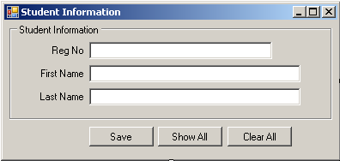

User of this UI will enter student information in textboxes and press Save button. (S)he will enter as many students as he wants.

All of the information will be displayed (as following format) in MessageBox when (s)he will click ‘Show All’ button.

Registration Number Full Name
02836748 Tauhidul Islam
038746734 Nadia Afreen
78476458 Zaman khan

All the information will be cleared as when ‘Clear All’ will be clicked.

Practice 3:

Practice 3 is same as Practice2. The difference is User only enters three students information here. If (s)he tries to enter more than three students, system will show a message: “Already three student has been saved.”

Practice 4: Keep some students (first name, last name) to a stack and show them using foreach loop.

Practice 5:

Make a simple Queue management application as following UI:

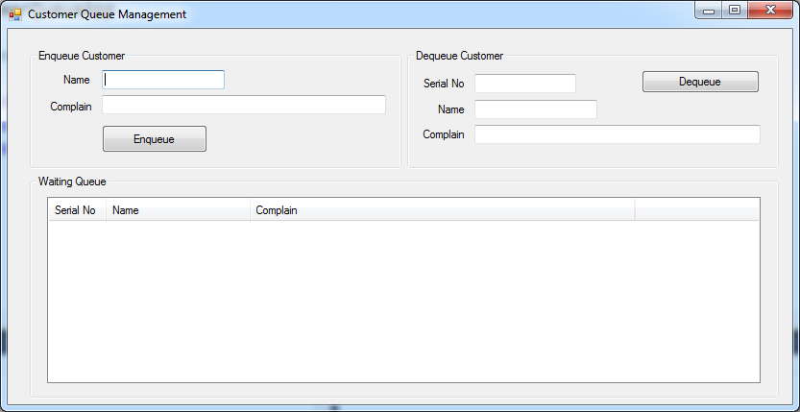

When information is given and click Enqueue button, application will be behaved as following UI:

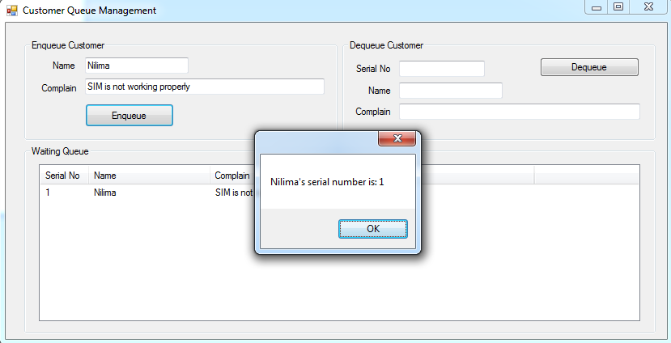

When Dequeue button has been click, Following UI:

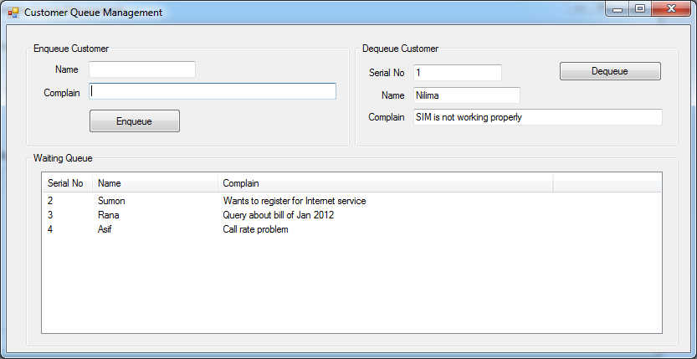

Using Hash Table:
Hashtable has few public methods as described below:

Public Methods | Description
Add | Add one object with one attribute which we will use as key to retrieve object quickly from the table.

Example:
In following example we will keep books in libraries using Hashtable and as a key of book we will use ISBN number in Hashtable.Using key we will retrieve book form from Hashtable.

using System;

namespace HashTableExample
{
/// <summary>
/// Book Class
/// </summary>
public class Book
{
private string isbnNumber;
private string title;

public Book(string title,string isbnNumber)
{
this.title = title;
this.isbnNumber = isbnNumber;
}
public string IsbnNumber
{
get { return isbnNumber; }
}

public string Title
{
get { return title; }
}
}
}

using System;
using System.Collections;

namespace HashTableExample
{
/// <summary>
/// Store book information and provide book information.
/// </summary>
public class Libary
{
private Hashtable bookList = null;
private Book bookObj;
public Libary()
{
bookList = new Hashtable();
}
/// <summary>
/// Add book information in Libary.
/// </summary>
/// <param name="isbnNumber"></param>
/// <param name="bookObj"></param>
public void AddBook(string isbnNumber, Book bookObj)
{
bookList.Add(isbnNumber, bookObj);
}
/// <summary>
/// Provide a book object.
/// </summary>
/// <param name="isbnNumber"></param>
/// <returns></returns>
public Book GetBook(string isbnNumber)
{
return bookObj = (Book) bookList[isbnNumber];
}
}
}

using System;

namespace HashTableExample
{
public class EntryPoint
{
public static void Main()
{
Libary libaryObj = new Libary();
Book bookObj1 = new Book("Database System Concept","Db#789");
Book bookObj2 = new Book("Begining C# 2008", "Pl#756");
Book bookObj3 = new Book("Head First C#", "pl#759");

libaryObj.AddBook(bookObj1.IsbnNumber, bookObj1);
libaryObj.AddBook(bookObj2.IsbnNumber, bookObj2);
libaryObj.AddBook(bookObj3.IsbnNumber, bookObj3);

Book bookObj = libaryObj.GetBook("Db#789");
Console.WriteLine(bookObj.Title);
Console.ReadLine();
}
}

The preceding code produces the following output:

Database System Concept

Dictionary Example:

